# Project GROW News

**In January,** we began our New Year greeting each other with, “Happy New Year!” at Morning Meeting time. We have enjoyed a theme of ‘Winter’ by talking about water and how it changes during the cold temperatures to either snow or ice. We also learned about the opposite of ‘freezing’, which is melting’.

We had an exciting game of ‘ice hockey’ using ice cubes and popsicle sticks on the tables with blocks used for our boundaries. We also went ‘ice skating’ in our bare feet on the floor in shaving cream! What fun!

We talked about the sizes, ‘big’, ‘medium’ and ‘small’, as we made snowmen in our journals. We created an ABC pattern on the calendar this month with big, medium and small sizes for our numbers.

We learned about the word, ‘hibernation’ and which animals sleep through the long months of winter. We placed animals that hibernate in one column and those that do not in another. We made birdfeeders out of pinecones, peanut butter and birdseed for the birds and squirrels that need food at this time of year!

We opened a veterinarian hospital and put dried beans in the sensory table.

We read the story, “The Mitten” by Jan Brett and acted out the book by having the children be one of the animals in the story. The children climbed into ‘the mitten’ and waited until the smallest animal crawled in and made the bear sneeze- Aaaaa-chooo!

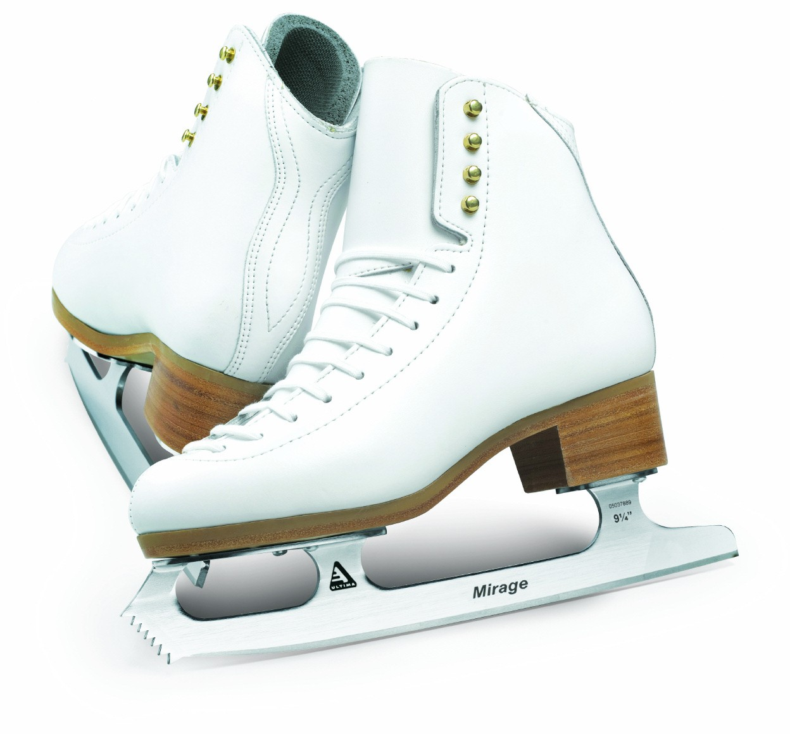

February 1, 2024

**.**

**Reminder:**

**Tuition is due on January 18th.**

Attached o the newsletter is an article from NAEYC (National Association for the Education of Young Children) on preschool age appropriate print awareness.

**Helpers for the month:**

For February, the color of the month is **purple.** The children continue to enjoy finding out who will be the helper each day in the classroom by using a visual chart with clues that help them to figure out who it is for the day!

**Happy Birthday in February to**:

**Mrs. Thuestad** on February 20th!

**Miss Larkin** on February 21st!



**THANK YOU TO:**



**Cedar** for paper towels!

**Ashton** for paper towels!

**Avery** & **Asher** for wipes and paper towels!

**Amelia** for making playdough!